**Sentiment Analysis with Vader and Roberta**

In this Sentiment Analysis we implemented a Vader and Roberta pretrained models on the ‘Comments’ data set. The results are shown as it follows.

**Amount of Ratings**

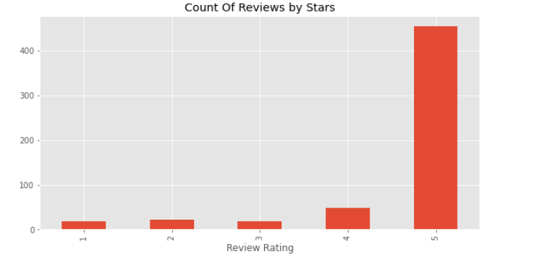

As it is seen above the most of the ratings accumulated on 5. That means we have lots of ‘5’ ratings.

**Vader Sentiment Analysis**

Vader is pre-trained ‘NLP’ library which is used to analyze text or sentence. The main purpose of Vader is Classifying the polarity of a given text at the document, sentence, or feature/aspect level—whether the expressed opinion in a document, sentence, or entity feature/aspect is positive, negative, or neutral—is a fundamental task in sentiment analysis. Advanced sentiment classification " polarity" considers emotional states such as ‘positive’,’negative’ , ‘neutral and ‘compound’.

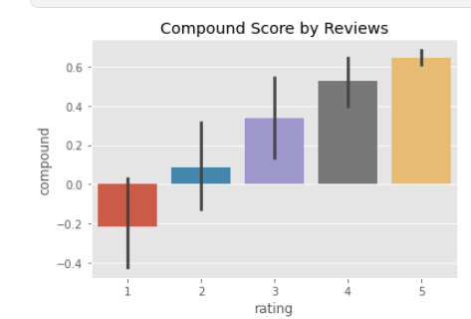

As it is shown above, the data set is the data set consists of relatively positive comments according to the vader library.

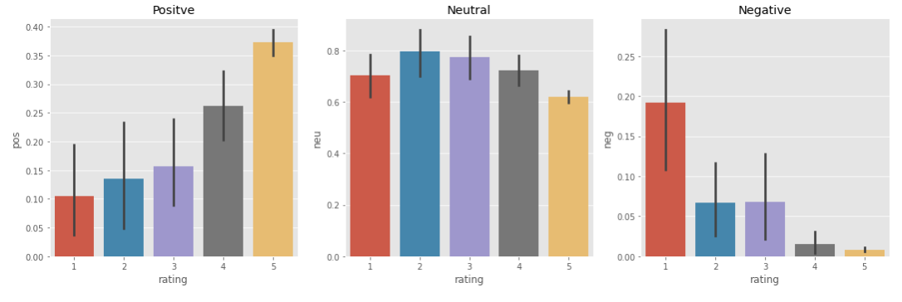

The data above has proved, the sentiment classification sentiment shows that the classification is working quite properly.

**Sentiment Analysis with Roberta**

Roberta is one of the pre-trained ‘NLP’ models to implement sentiment analysis on text and Word. Roberta is similar to Vader in several points much more better than Vader.

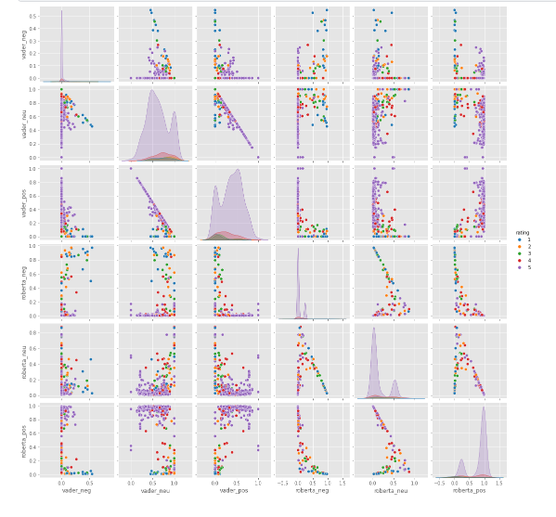

Comparing to Vader Roberta gave us better results on sentiment analysis.

**Recommendations**

The most important suggestion to be made to the company in this section is to update the tabs for website comments and make it mandatory for customers to comment in the comment tabs.